app.js

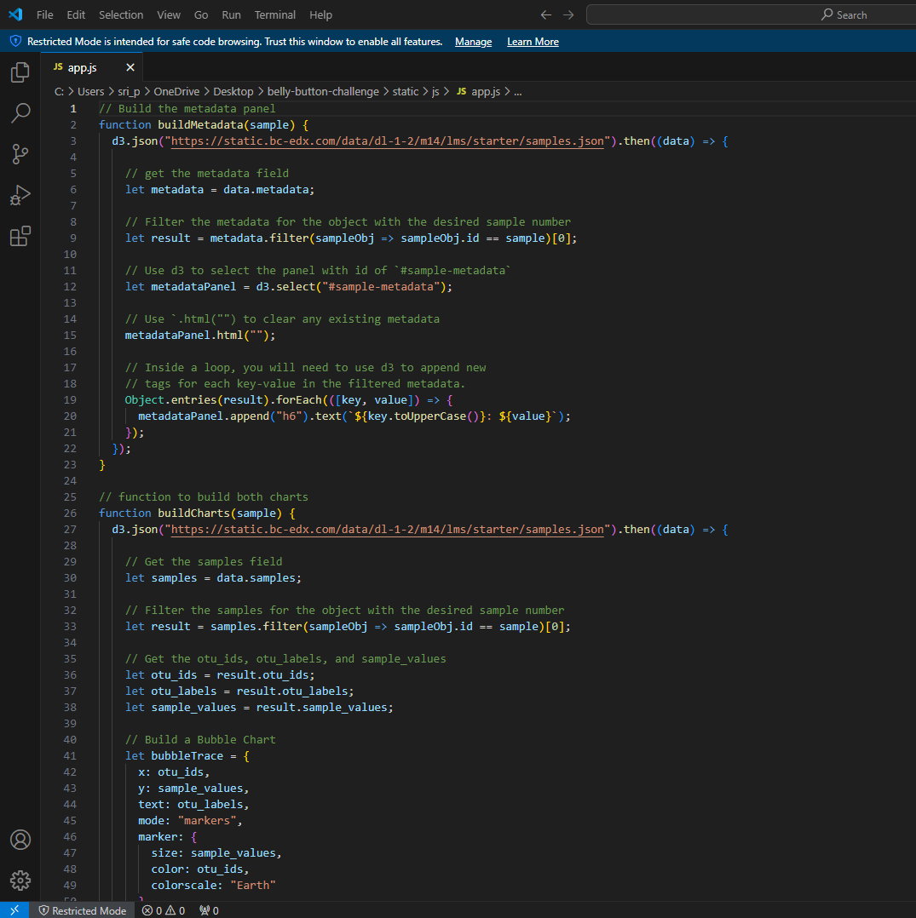

Index.html

Belly Button Biodiversity Dashboard



